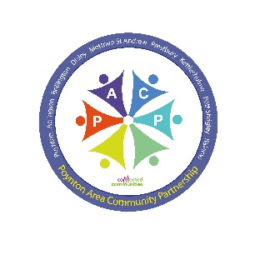 | Poynton Area Community Partnership  Grant Application Form | 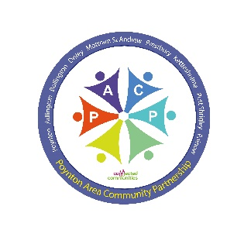
The Poynton Area Community Partnership (PACP) is given a budget by Cheshire East to help kickstart new projects or initiatives by the community for the community. Typically, grants of around £250-£500 are awarded. The Parishes covered by PACP are shown on page 4.

Who can apply, and for what sort of projects?
1. Voluntary organisations, societies or groups of volunteers in our Partnership area may apply
2. We welcome sustainable projects or initiatives which can be shown to benefit our communities, and which empower or encourage volunteers. As we begin to recover from the effects of Covid-19 priorities will include combatting social isolation, and improving mental and physical wellbeing.
3. Projects must also fit within the criteria laid down by Cheshire East, as reflected in the PACP Action Plans. The project must satisfy one (preferably more) of the following outcomes:

1. | Social Innovation – help people identify their community needs, and get people involved in local initiatives, developing local solutions for local needs.
2. | Communities are better connected – bringing existing resources together to work collaboratively, strengthening local connections with other agencies
3. | Increased knowledge and accessibility to existing services/assets – develop relationships to help improve local communication, and ensure information about local services is widely known.
4. | Decreased demand on public services – develop local assets and/or projects/activities which keep people safe and well, and reduce escalating needs

Do any conditions apply?
1. As these grants aim to help kickstart/develop new initiatives which will benefit your community, grants are not available for projects or initiatives which are existing or ongoing core activities of the applying group, or which should properly be funded from Council budgets.
2. Applications must clearly demonstrate value - they must (1) indicate the number of volunteer hours the project generates, (2) the amount of external grants etc secured or actively being sought, and (3) the local fundraising/donations secured for the project.
3. It is a condition of the grant that you complete a feedback form within a month of establishing the project or initiative, where possible providing photograph(s). It is essential that your feedback must specifically confirm detail of the 3 measures in 2 above.

Anything else you should know?
1. Any unspent grant must be returned promptly to the Partnership. Flexibility can be agreed in longer term/large scale projects where additional funding is being sought. In such cases, progress reports could be required, with any unspent grant returned at the project’s conclusion.
2. Further applications for the same project within a 12-month period will not be considered.
3. The Grants Sub-Group of PACP considers applications and communicates decisions promptly.

1. Name and full address of your organisation/society

2. Name and contact details of the person applying and role in the organisation/group.

3. Provide a brief outline of your organisation’s/society’s interests, aims and objectives (in 200 words or less)

4. Is it a registered charity? If so, please provide the Charity number.

YES/NO Registered Charity number:

5. How many active members does it have currently? Of these, what proportion are local residents? Will the project benefit non-members of your organisation, and if so, how many people in your community are likely to benefit?

6. Please provide a brief description of the project, event or programme for which funding is sought, including timescales for its completion (in 200 words or less).

7. How (in 200 words or less) will this project, event or programme specifically meet one or more of the 4 outcomes on page 1?

8. To what extent is the project, event or programme sustainable? (in 200 words or less).

9. What is the overall cost of the project, event or programme, and what level of funding are you seeking from Poynton Area Community Partnership?

10. Please tell us about how and where you have sourced other external grants/funding for your project, and with what success? We will favour applications that are currently exploring or have already secured other funding.

11. Please provide details of the number of volunteer hours by members of your community that you expect will be generated by this project

12. Please tell us about the number and amount of local donations you have secured (or hope to secure) towards the costs of this project.

Signed ……………………………………… Print name ……………………………………...

Position/Title ………………………………………………. Date ………………………………

Contact email address ……………………………………

NB. Successful grant applications are paid by BACS – please can you provide your organisation’s bank details:

Account Number & Sort Code:

Exact Name on the Account:

Please now return the completed form to Sharon.Duke@poyntontowncouncil.gov.uk

or send/deliver to: P.A.C.P. c/o Civic Hall, Park Lane, Poynton, SK12 1RB

PACP covers Adlington, Bollington, Disley, Kettleshulme, Mottram St Andrew, Rainow,
Pott Shrigley, Prestbury, and Poynton. Our website is
http://www.poyntontowncouncil.gov.uk/Poynton_Area_Community_Partnership_38434.aspx

v0621

