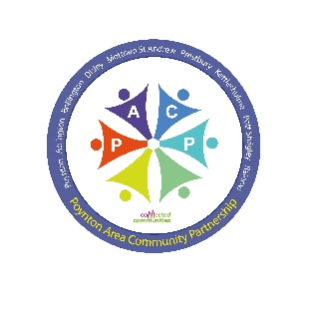 | Poynton Area Community Partnership  (PACP)  Grant Application Form | 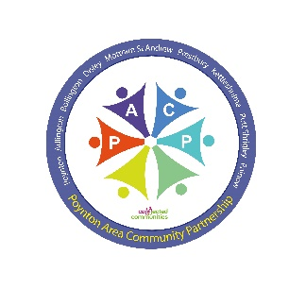

The Poynton Area Community Partnership (PACP) has a budget to help fund community projects, events or programmes in our area. Typically, grants of around £250-£500 are available.

Who can apply, and for what sort of projects?
1. Only bona fide voluntary organisations or societies based in our Partnership area may apply
2. We welcome projects, events or programmes that are sustainable and can be shown to benefit our communities.
3. Projects must fit within the criteria laid down by Cheshire East, as reflected in the PACP Action Plans. The project must satisfy one or more of the following outcomes:

1. | Social Innovation – help people identify their community needs, and get involved in local initiatives, developing local solutions for local needs.
2. | Communities are better connected – bringing existing resources together to work collaboratively, strengthening local connections with other agencies
3. | Increased knowledge and accessibility to existing services/assets – develop relationships to help improve local communication, and ensure information about local services is widely known.
4. | Decreased demand on public services – develop local assets and/or projects/activities which keep people safe and well, and reduce escalating needs

Do any conditions apply?
1. If your application is successful, you must complete a feedback form within a month of completion of the project, event or programme and where possible provide a photograph.
2. Any unspent grant must be returned to the Poynton Area Community Partnership within one month of the award. Flexibility can however be given to longer term/large scale projects where additional funding is being sought. In such cases, progress reports could be required, with any unspent grant returned at the conclusion of the project
3. Applications must clearly demonstrate value for money. Measures include the number of community volunteer hours the project generates, the amount of external grants or other sources of funding secured or actively being sought, and any local monetary donations secured for the project.

Anything else you should know?
1. Grants are not available for projects, events or programmes which are ‘core activity’ for the applying group.
2. Multiple applications for the same project within a 12-month period will not be considered.
3. The application process will be assessed by the Poynton Area Community Partnership funding subgroup, which will communicate its decisions as soon as possible.

1. Name and full address of your organisation/society

2. Name and contact details of the person applying and role in the organisation/group.

3. Provide a brief outline of your organisation’s/society’s interests, aims and objectives (in 200 words or less)

4. Is it a registered charity? If so, please provide the Charity number.

YES/NO Registered Charity number:

5. How many active members does it have currently? Of these, what proportion are local residents? Will the project benefit non-members of your organisation, and if so, how many people in your community are likely to benefit?

6. Please provide a brief description of the project, event or programme for which funding is sought, including timescales for its completion (in 200 words or less).

7. How (in 200 words or less) will this project, event or programme specifically meet one or more of the 4 outcomes on page 1?

8. To what extent is the project, event or programme sustainable? (in 200 words or less).

9. What is the overall cost of the project, event or programme, and what level of funding are you seeking from Poynton Area Community Partnership?

10. Please tell us about how and where you have sourced other external grants/funding for your project, and with what success? We will favour applications that are currently exploring or have already secured other funding.

11. Please provide the total number of volunteer hours by members of your community that you expect will be generated by this project

12. Please tell us about the number and amount of local donations you have secured (or hope to secure) towards the costs of this project.

Signed ……………………………………… Print name ……………………………………...

Position/Title ………………………………………………. Date ………………………………

Contact email address ……………………………………

NB. Successful grant applications are paid by BACS – please can you provide your organisation’s bank details:

Account Number & Sort Code:

Exact Name on the Account:

Please now return the completed form to Sharon.Duke@poyntontowncouncil.gov.uk

or send/deliver to: P.A.C.P. c/o Civic Hall, Park Lane, Poynton, SK12 1RB

Further details can be found at
https://www.poyntontowncouncil.gov.uk/poynton-area-community-partnership.htm

v1Dec2020

